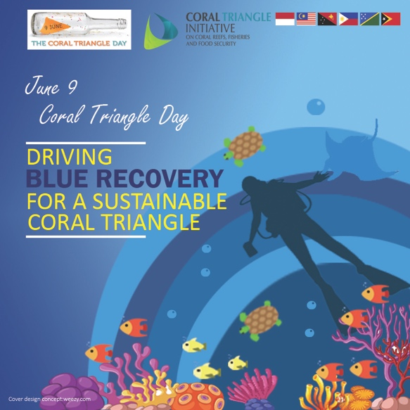

Coral Triangle Day 2021
“Driving Blue Recovery for A Sustainable Coral Triangle”
9 June 2021 | 9:00 AM – 11:30 AM (GMT+8)

DRAFT PROGRAM

Time | Topic and Resource Person
9:00 AM – 10:10 AM | Welcome Remarks  Dr. Mohd Kushairi Mohd Rajuddin  Executive Director, CTI-CFF Regional Secretariat
10:10 AM – 10:30 AM | Topic 1: Science and Innovation for a Blue Recovery  Dr Ian McLeod  Associate Professor  James Cook University /  Australian Institute of Marine Science
10:30 AM – 10:50 AM | Topic 2: Financing and Investing in Blue Recovery  Mr Yabanex Batista  Chief Executive Officer  Caribbean Biodiversity Fund  The Bahamas
10:50 AM – 11: 10 AM | Topic 3: Creating and communicating value from Blue Recovery  The Reef Joint Field Management Program and GBRMPA’s Partnership with First Nations People  Dr Mark Read  Acting Director Field Management Strategy  Great Barrier Reef Marine Park Authority
11:10 AM-11:30 AM | Q&A and Closing

